Ex. No.: 3

Reg. No. : 210701092

**Map Reduce program to process a weather dataset**

**Input(dataset.txt):**

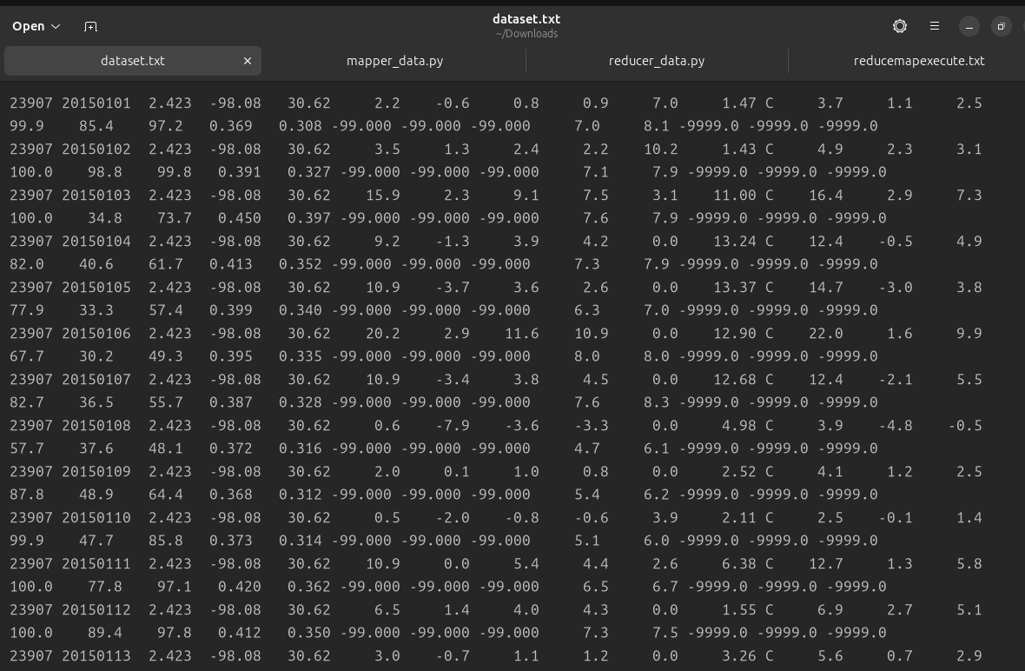

**mapper_data.py:**

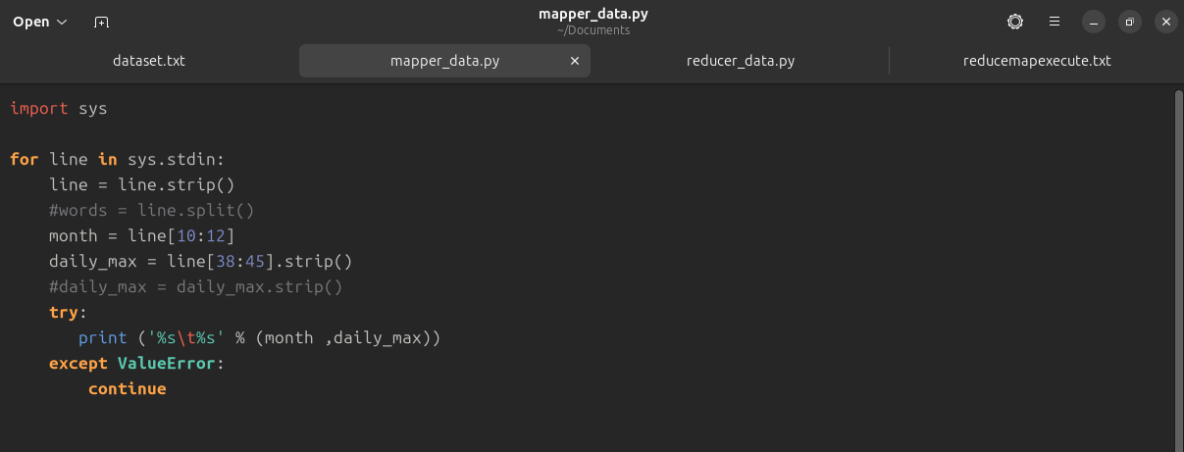

**reducer_data.py:**

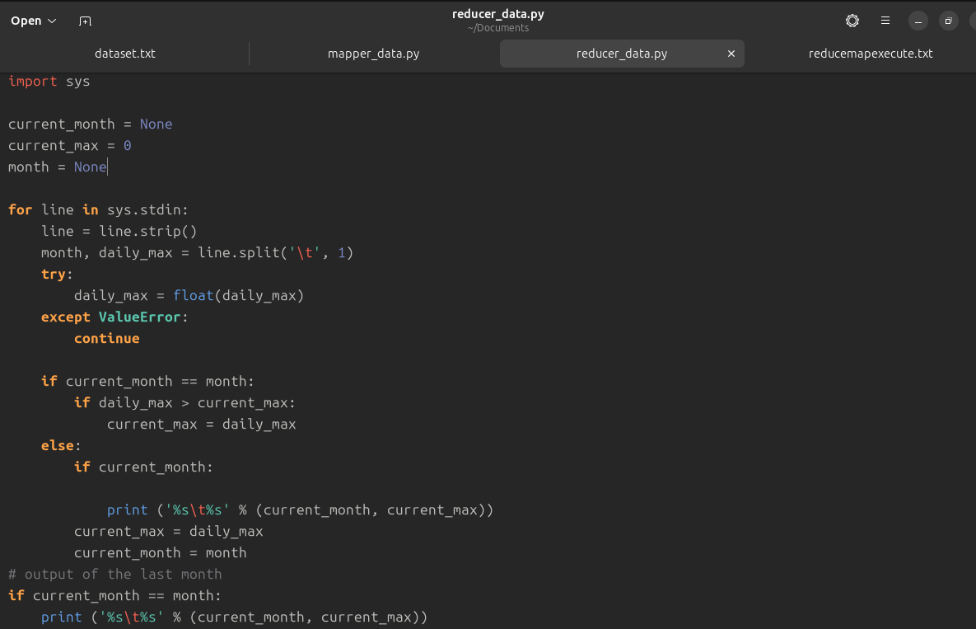

**Output:**

